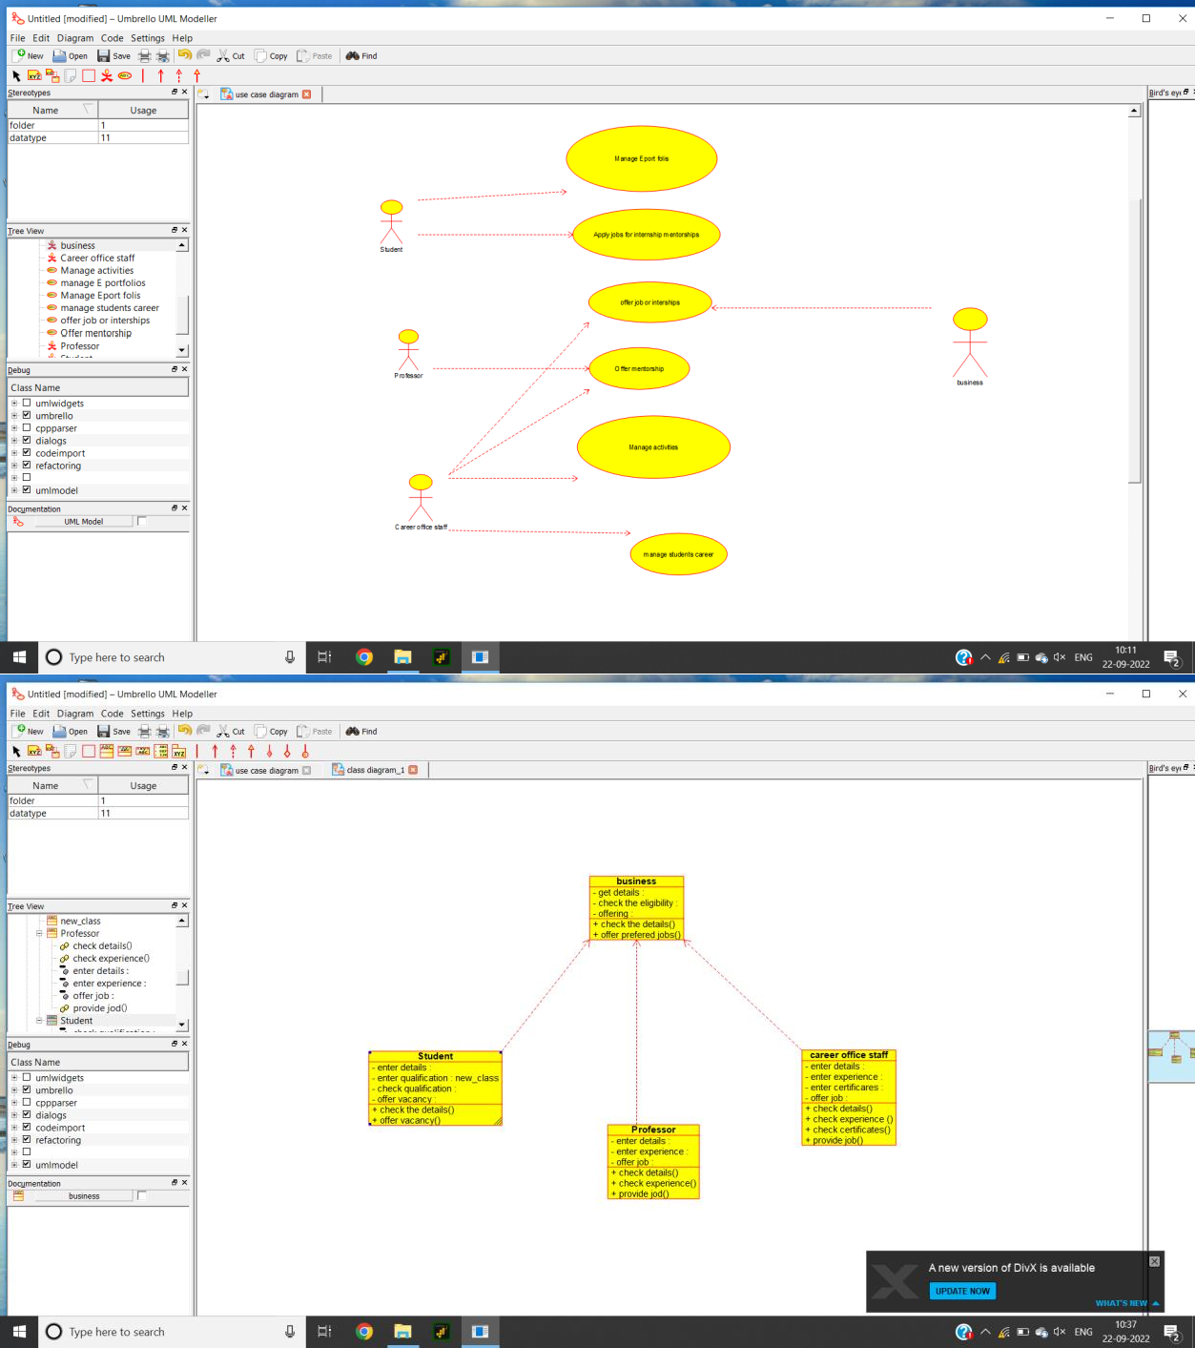

/**

* Class business

*/

public class business {

//

// Fields

//

private void get_details;

private void check_the_eligibility; private void offering;

//

// Constructors

//

public business () { };

//

// Methods

//

//

// Accessor methods

//

/**

* Set the value of get_details
* @param newVar the new value of get_details

*/

private void setGet_details (void newVar) { get_details = newVar;

}

/**

* Get the value of get_details
* @return the value of get_details

*/

private void getGet_details () { return get_details;

}

/**

* Set the value of check_the_eligibility
* @param newVar the new value of check_the_eligibility

*/

private void setCheck_the_eligibility (void newVar) { check_the_eligibility = newVar;

}

/**

* Get the value of check_the_eligibility
* @return the value of check_the_eligibility

*/

private void getCheck_the_eligibility () { return check_the_eligibility;

}

/**

* Set the value of offering
* @param newVar the new value of offering

*/

private void setOffering (void newVar) { offering = newVar;

}

/**

* Get the value of offering
* @return the value of offering

*/

private void getOffering () { return offering;

}

//

// Other methods

//

/**

*/

public void check_the_details()

{

}

/**

*/

public void offer_prefered_jobs()

{

}

}

/**

* Class Student

*/

public class Student {

//

// Fields

//

//

// Constructors

//

public Student () { };

//

// Methods

//

//

// Accessor methods

//

//

// Other methods

//

/**

*/

public void new_operation()

{

}

/**

*/

public void valid()

{

}

/**

*/

public void return_books()

{

}

}

/**

* Class Professor

*/

public class Professor {

//

// Fields

//

private void enter_details; private void enter_experience; private void offer_job;

//

// Constructors

//

public Professor () { };

//

// Methods

//

//

// Accessor methods

//

/**

* Set the value of enter_details
* @param newVar the new value of enter_details

*/

private void setEnter_details (void newVar) { enter_details = newVar;

}

/**

* Get the value of enter_details
* @return the value of enter_details

*/

private void getEnter_details () { return enter_details;

}

/**

* Set the value of enter_experience
* @param newVar the new value of enter_experience

*/

private void setEnter_experience (void newVar) { enter_experience = newVar;

}

/**

* Get the value of enter_experience
* @return the value of enter_experience

*/

private void getEnter_experience () { return enter_experience;

}

/**

* Set the value of offer_job
* @param newVar the new value of offer_job

*/

private void setOffer_job (void newVar) { offer_job = newVar;

}

/**

* Get the value of offer_job
* @return the value of offer_job

*/

private void getOffer_job () {

return offer_job;

}

//

// Other methods

//

/**

*/

public void check_details()

{

}

/**

*/

public void check_experience()

{

}

/**

*/

public void provide_jod()

{

}

}

/**

* Class career_office_staff

*/

public class career_office_staff {

//

// Fields

//

private void enter_details; private void enter_experience; private void enter_certificares; private void offer_job;

//

// Constructors

//

public career_office_staff () { };

//

// Methods

//

//

// Accessor methods

//

/**

* Set the value of enter_details
* @param newVar the new value of enter_details

*/

private void setEnter_details (void newVar) { enter_details = newVar;

}

/**

* Get the value of enter_details
* @return the value of enter_details

*/

private void getEnter_details () { return enter_details;

}

/**

* Set the value of enter_experience
* @param newVar the new value of enter_experience

*/

private void setEnter_experience (void newVar) { enter_experience = newVar;

}

/**

* Get the value of enter_experience
* @return the value of enter_experience

*/

private void getEnter_experience () { return enter_experience;

}

/**

* Set the value of enter_certificares
* @param newVar the new value of enter_certificares

*/

private void setEnter_certificares (void newVar) { enter_certificares = newVar;

}

/**

* Get the value of enter_certificares
* @return the value of enter_certificares

*/

private void getEnter_certificares () { return enter_certificares;

}

/**

* Set the value of offer_job
* @param newVar the new value of offer_job

*/

private void setOffer_job (void newVar) { offer_job = newVar;

}

/**

* Get the value of offer_job
* @return the value of offer_job

*/

private void getOffer_job () { return offer_job;

}

//

// Other methods

//

/**

*/

public void check_details()

{

}

/**

*/

public void check_experience_()

{

}

/**

*/

public void check_certificates()

{

}

/**

*/

public void provide_job()

{

}

}